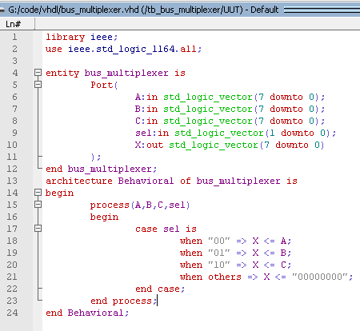
Program 1: VHDL 8:1 Bus Multiplexer

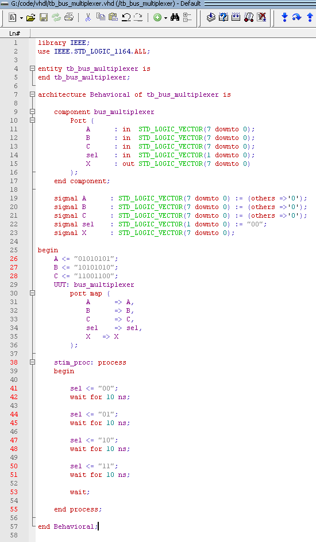
Program 2: VHDL Testbench for Bus Multiplexer
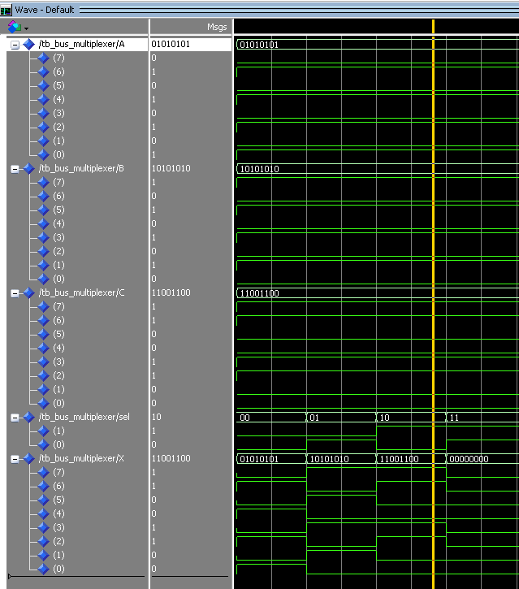
Testbench Output: Simulation Waveform of 8:1 Bus Multiplexer

